**Registration Form**

Welcome to the Children’s Museum Preschool! We are so happy that you have chosen our school to begin your child’s educational journey. Please complete this portion and return with your $100 non-refundable registration fee to begin the process for a preschool placement for your child. Please print.

**Child’s Name ___________________________________________**

**Age 2.5 3 4 5 Date of Birth ________________**

**\*** Children must be 32 months of age *and* toilet trained to begin our program.

**With whom does the child live? ___________________________**

**Parent Name ___________________________________________**

**Home Address** ______________________________________

**Work Address**_______________________________________

**Phone (home)____________________(cell)__________________**

**(work)____________________**

**Parent Name ___________________________________________**

**Address (if different)** _________________________________

**Work Address** ______________________________________

**Phone (home)____________________(cell)__________________**

**(work)____________________**

**Child will attend school which days? Please circle.**

**M T W Th F**

**Start date _____________**

**Will your child continue through July & August? Please circle YES NO**

**Please choose one: _____ Part-time Preschool AM (9am – 12pm)**

**_____Full-time Preschool _____ am - ____pm**

**____________________________________ __________________**

**Parent Signature Date**

____________________________________________________

**Preferred Email Address**

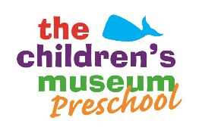**The Children’s Museum Preschool**

950 Trout Brook Dr. West Hartford, CT

860-523-7449

**“Where Learning is Child’s Play”**

Program Philosophy

The Children’s Museum Preschool is a **play-based program** that encourages and develops learning through each child’s natural activities. Experts agree that by learning through play, children will find education to be a positive and joyous process. Our focus on this philosophy is at the core of our curriculum.

We know that all children are different, and each one comes to us with different strengths and areas for growth. Using proven techniques and following the CT Early and Development Standards, we tailor our classes to be sensitive to the needs of each individual child while maintaining an affirming and inclusive environment for all.

Our experienced and degreed educators encourage children to explore, imagine and create which, in turn, enhances and develops each child’s critical thinking skills, scientific understanding, mathematic skills, creativity and ability to express themselves. We structure our classes and activities to facilitate the growth of important social skills such as: sharing, taking turns, and respecting the rights of others.

A typical school day includes activities and experiential learning that enhance social, emotional, intellectual, and physical growth. Each week on a rotating basis, our children experience developmentally appropriate planetarium shows and science classes taught by museum educators, as well as animal demonstrations with our wildlife sanctuary staff. Children in the preschool often explore the museum with their teachers as guides. As an added bonus, Preschool Families receive a **Museum Family Membership** giving families the opportunity to visit and explore the museum together.

As children progress through our program, they learn the skills that give them a wonderful start in the lifelong journey of learning. We are looking forward to adding your family to our family, here at the Children’s Museum Preschool.

Meet the Staff:

**LoriAnne Crochetiere: Preschool Director**

[**lcrochetiere@thechildrensmuseumct.org**](mailto:lcrochetiere@thechildrensmuseumct.org)

Miss Lori has her Connecticut Director’s Credential, and her Bachelor’s in Elementary Education, specializing in Early Childhood. Miss Lori comes with over 30 years of experience in the Early Childhood field. Favorite Activities: Music and Movement or reading stories with her favorite people… The Children’s Museum Preschoolers. Favorite Day: Pajama Day!

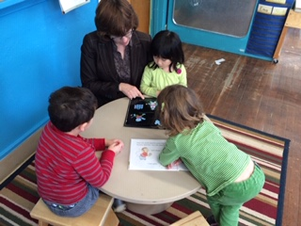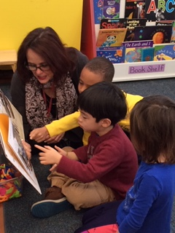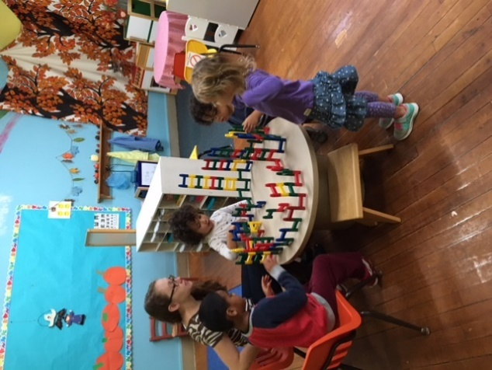

**Julie Bostrom: Assistant Director/ Head Teacher Pre K 4/5**

Miss Julie has degrees in Psychology/Child Psychology and Early Childhood, and brings 25 years of experience teaching Pre-K and Kindergarten. Using Lively Letter program and Letter Bags, she makes phonics fun!

**Christina Maldonado: Head Teacher Pre-K 4**

Miss Christina has her Early Childhood Teaching Certificate (113) and brings over 10 years of experience in Early Childhood in both the private sector and public schools. Morning Meetings and Weekly Letter Songs are a hit in this classroom.

**Ivorine Martell: Head Teacher Pre-K 3**

Miss Ivy has her Early Childhood degree and has worked teaching preschoolers for 11 years. Laughter is heard often in the room with the littlest preschoolers. Favorite Day: Friday Dance Party Day

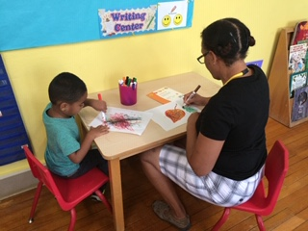 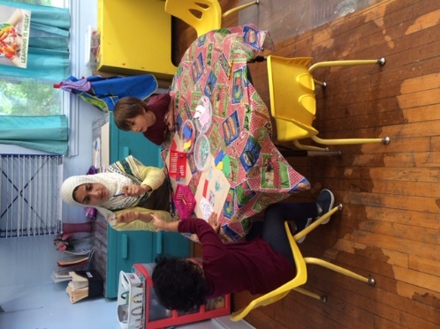 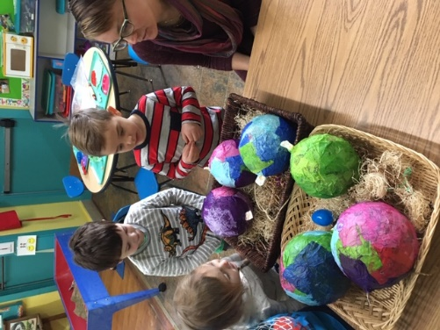

The Children’s Museum Preschool 2019 Tuition Rates

**Part-time Preschool 9 am – 12 pm**

**# Days Per Week Weekly Payments**

**3 $170**

**4 $190**

**5 $210**

* Tuition is paid for the upcoming week, payment due first day of school.
* Lunch Bunch (12 pm - 1pm) is available at a cost of $10 per day.
* Early Arrival only (8 am -9 am) is available at a cost of $10 per day.
* Part-time preschool can be an Academic Year September-June Schedule, or Full Year. We do not follow West Hartford Public School’s Calendar. School is closed New Year’s Day, Memorial Day, Independence Day, Labor Day, Thanksgiving Day and the day after, Christmas Day and the day after, two development days and one med. training day.

**Full-time Preschool 8 am – 5 pm Year ‘Round**

**# Days Per Week Weekly Payments**

**3 $260**

**4 $280**

**5 $300**

* Full-time tuition is based on 9 hours- not discounted for fewer hours.
* School is closed New Year’s Day, Memorial Day, Independence Day, Labor Day, Thanksgiving Day and the day after, Christmas Day and the day after, two development days and one med. training day.
* **Partial Scholarships available for full time/full year families below 75% of the state’s median income.**

**Care for Kids Subsidy Program**

The Children’s Museum Preschool participates in the

Connecticut Care 4 Kids Program.